Pangalan: _________________________________________ Baitang: _________

Paaralan: ______________________________________________

Guro: __________________________________________________

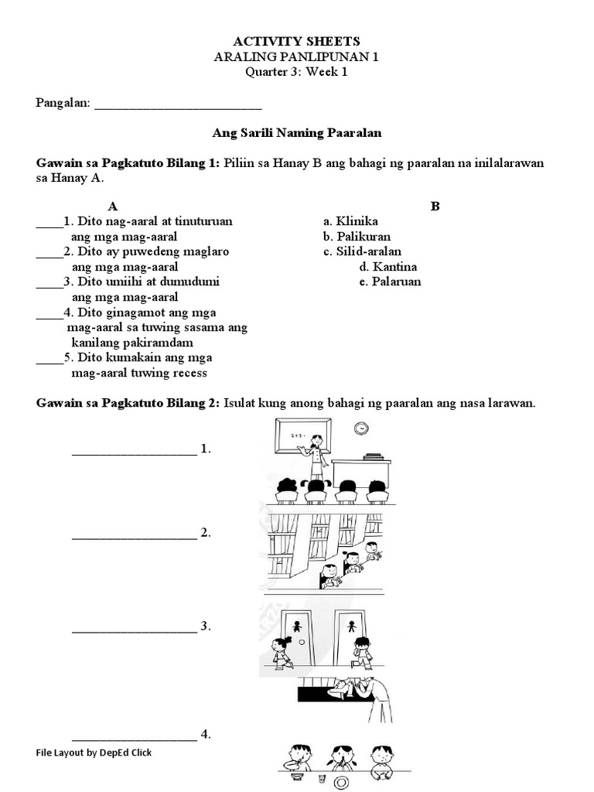**Araling Panlipunan1**